**Image Processing**

**Vahagn Adunts**

After lots of experiment in imageJ, I have noticed an interesting pattern to detect lips from images. It work on 4 images out of 5.

Steps

Open two images in imageJ

On the first image

1. Smoothen the first image with mean 2
2. Extract binary layer 2
3. Make the image binary
4. Fill the holes
5. Erode the image

On the second image

1. Smoothen the first image with mean 2
2. Make the image binary
3. Find the edges

After this procedure AND both of the images with the image calculator. If it is necessary you can fill the holes

Original image First step

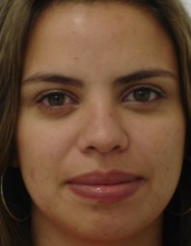 

Second step Resulting lips

 

Original image First step

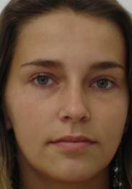 

Second step Resulting lips

 

Original image First step

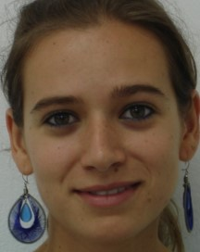 

Second step Resulting lips

 

Original image First step

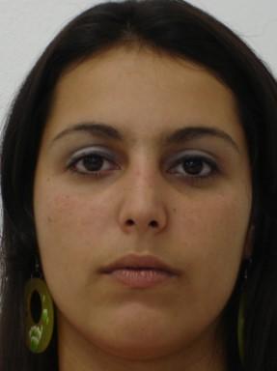 

Second step Resulting lips

 